Christ Evangelical Lutheran Church
May 7, 2023
Fifth Sunday of Easter

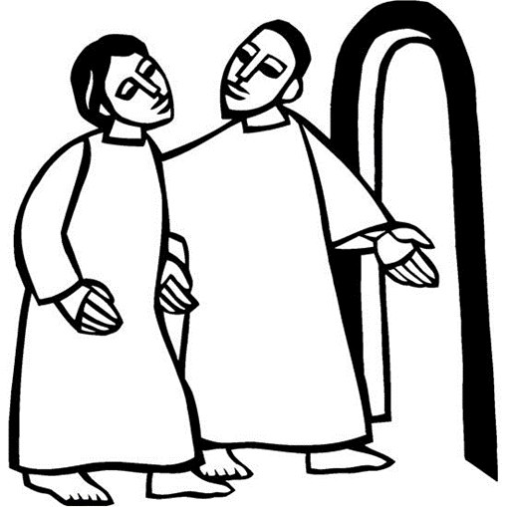

ALL ARE WELCOME HERE!
Gospel in Action: Caring for all God’s children, we shall serve God through worship, learning, and sharing.

Christ Evangelical Lutheran Church
32747 Lake Road
Avon Lake, Ohio 44012
440-933-6263
celc.mainoffice@gmail.com www.christlutheranavonlake.org
Interim Pastor: Rev. Laura Kuntz
Office Administrator: Heather Nordman
Organist: Randi Smarsh Custodians: Bill Higgins and Beth Lecorchick

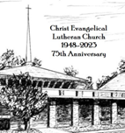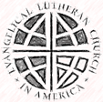

Order of worship
ANNOUNCEMENTS

PRELUDE
The congregation is invited to stand.

THANKSGIVING FOR BAPTISM
P: Blessed be the holy Trinity, ☩ one God, by whose hand we are given new birth, by whose speaking we are given new life.
C: Amen.
P: Joined to Christ in the waters of baptism, we are welcomed, restored, and supported as citizens of the new creation. Let us give thanks for the gift of baptism. Holy God, holy and merciful, holy and mighty, you are the river of life, you are the everlasting wellspring. In mercy and might you have freed us from death and raised us with Jesus, the firstborn of the dead. In baptismal waters our old life is washed away, and in them we are born anew.
Water may be poured into the font as the presiding minister continues.
P: Glory to you for oceans and lakes, for rivers and streams. Honor to you for waters that wash us clean, quench our thirst, and nurture both crops and creatures. Praise to you for the life-giving water of baptism, the outpouring of the Spirit of the new creation.
C: Wash away our sin and all that separates us from you. Empower our witness to your resurrection. Strengthen our resolve in seeking justice for all.
P: Satisfy the world’s need through this living water. Where drought dries the earth, bring refreshment. Where despair prevails, grant hope. Where chaos reigns, bring peace. We ask this through Christ, who with you and the Spirit reigns forever.
C: Amen.

GATHERING HYMN
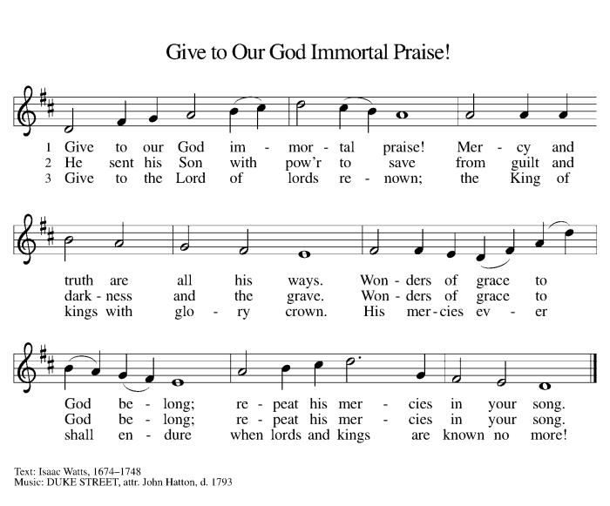

Greeting
P: The grace of our Lord Jesus Christ, the love of God, and the communion of the Holy Spirit be with you all.
C: And also with you.

HYMN OF PRAISE

Prayer of the Day
P: Let us pray.
C: Almighty God, your Son Jesus Christ is the way, the truth, and the life. Give us grace to love one another, to follow in the way of his commandments, and to share his risen life with all the world, for he lives and reigns with you and the Holy Spirit, one God, now and forever.
Amen.

The congregation is invited to sit.

FIRST LESSON Acts 7:55-60

L: The first lesson is from Acts, the 7th chapter.
⁵⁵Filled with the Holy Spirit, [Stephen] gazed into heaven and saw the glory of God and Jesus standing at the right hand of God. ⁵⁶“Look,” he said, “I see the heavens opened and the Son of Man standing at the right hand of God!” ⁵⁷But they covered their ears, and with a loud shout all rushed together against him. ⁵⁸Then they dragged him out of the city and began to stone him; and the witnesses laid their coats at the feet of a young man named Saul. ⁵⁹While they were stoning Stephen, he prayed, “Lord Jesus, receive my spirit.” ⁶⁰Then he knelt down and cried out in a loud voice, “Lord, do not hold this sin against them.” When he had said this, he died.
L: The word of the Lord!
C: Thanks be to God!

PSALM 31:1-5, 15-16
TONE
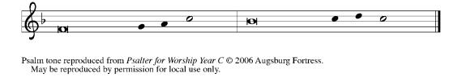
REFRAIN
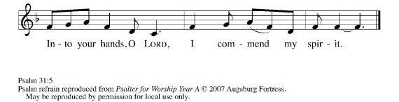
¹In you, O Lord, have I taken refuge; let me never be | put to shame;
deliver me | in your righteousness.
²Incline your | ear to me;
make haste to de- | liver me.
³Be my strong rock, a castle to keep me safe, for you are my crag | and my stronghold;
for the sake of your name, lead | me and guide me.
⁴Take me out of the net that they have secretly | set for me,
for you are my tow- | er of strength. R
⁵Into your hands I com- | mend my spirit,
for you have redeemed me, O Lord, | God of truth.
¹⁵My times are | in your hand;
rescue me from the hand of my enemies, and from those who | persecute me.
¹⁶Let your face shine up- | on your servant;
save me in your | steadfast love.” R

SECOND LESSON 1 peter 2:2-10

L: The second lesson is from 1 Peter, the 2nd chapter.
²Like newborn infants, long for the pure, spiritual milk, so that by it you may grow into salvation—³if indeed you have tasted that the Lord is good. ⁴Come to him, a living stone, though rejected by mortals yet chosen and precious in God’s sight, and ⁵like living stones, let yourselves be built into a spiritual house, to be a holy priesthood, to offer spiritual sacrifices acceptable to God through Jesus Christ. ⁶For it stands in scripture: “See, I am laying in Zion a stone, a cornerstone chosen and precious; and whoever believes in him will not be put to shame.” ⁷To you then who believe, he is precious; but for those who do not believe, “The stone that the builders rejected has become the very head of the corner,” ⁸and “A stone that makes them stumble, and a rock that makes them fall.” They stumble because they disobey the word, as they were destined to do. ⁹But you are a chosen race, a royal priesthood, a holy nation, God’s own people, in order that you may proclaim the mighty acts of him who called you out of darkness into his marvelous light. ¹⁰Once you were not a people, but now you are God’s people; once you had not received mercy, but now you have received mercy.
L: The word of the Lord!
C: Thanks be to God!

CHILDREN’S SERMON
The congregation is invited to stand.
GOSPEL ACCLAMATION
Gospel John 14:1-14
P: The Holy Gospel according to St. John, the 14th chapter.
C: Glory to you, O Lord!
[Jesus said to the disciples:] ¹“Do not let your hearts be troubled. Believe in God, believe also in me. ²In my Father’s house there are many dwelling places. If it were not so, would I have told you that I go to prepare a place for you? ³And if I go and prepare a place for you, I will come again and will take you to myself, so that where I am, there you may be also. ⁴And you know the way to the place where I am going.” ⁵Thomas said to him, “Lord, we do not know where you are going. How can we know the way?” ⁶Jesus said to him, “I am the way, and the truth, and the life. No one comes to the Father except through me. ⁷If you know me, you will know my Father also. From now on you do know him and have seen him.” ⁸Philip said to him, “Lord, show us the Father, and we will be satisfied.” ⁹Jesus said to him, “Have I been with you all this time, Philip, and you still do not know me? Whoever has seen me has seen the Father. How can you say, ‘Show us the Father’? ¹⁰Do you not believe that I am in the Father and the Father is in me? The words that I say to you I do not speak on my own; but the Father who dwells in me does his works. ¹¹Believe me that I am in the Father and the Father is in me; but if you do not, then believe me because of the works themselves. ¹²Very truly, I tell you, the one who believes in me will also do the works that I do and, in fact, will do greater works than these, because I am going to the Father. ¹³I will do whatever you ask in my name, so that the Father may be glorified in the Son. ¹⁴If in my name you ask me for anything, I will do it.”
P: The gospel of the Lord!
C: Praise to you, O Christ!
The congregation is invited to sit.

Sermon Rev. Laura Kuntz

The congregation is invited to stand.
Hymn of the Day
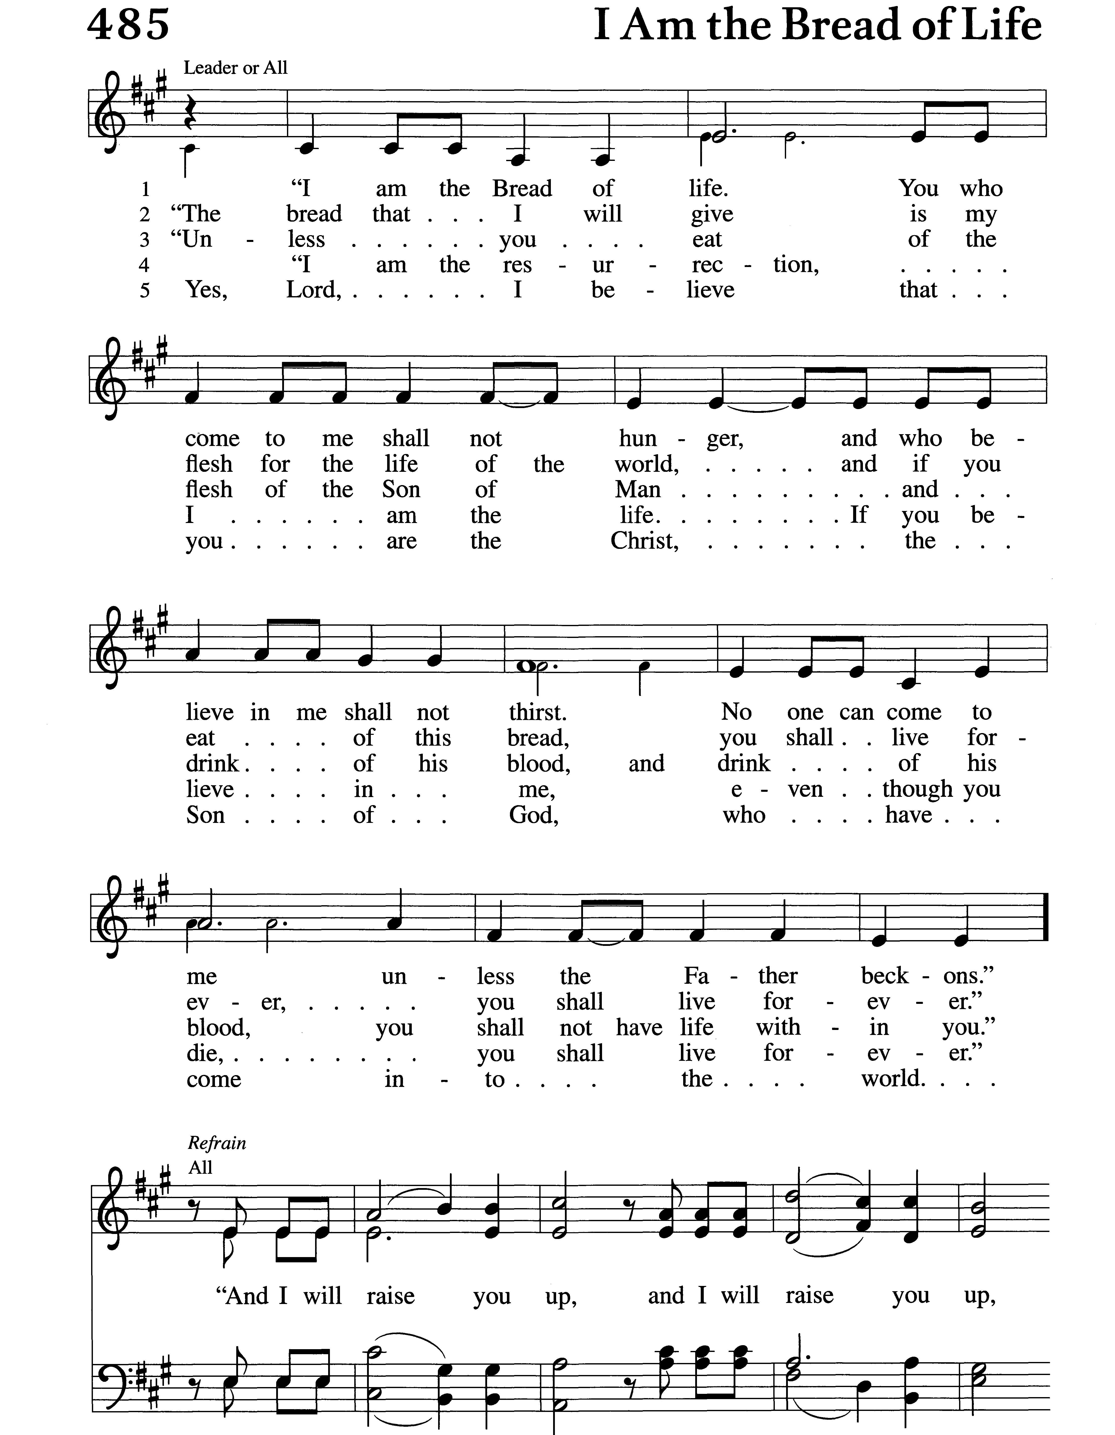

NICENE CREED
C: We believe in one God, the Father, the Almighty, maker of heaven and earth, of all that is, seen and unseen. We believe in one Lord, Jesus Christ, the only Son of God, eternally begotten of the Father, God from God, Light from Light, true God from true God, begotten, not made, of one Being with the Father; through him all things were made. For us and for our salvation he came down from heaven, was incarnate of the Holy Spirit and the virgin Mary and became truly human. For our sake he was crucified under Pontius Pilate; he suffered death and was buried. On the third day he rose again in accordance with the scriptures; he ascended into heaven and is seated at the right hand of the Father. He will come again in glory to judge the living and the dead, and his kingdom will have no end. We believe in the Holy Spirit, the Lord, the giver of life, who proceeds from the Father and the Son, who with the Father and the Son is worshiped and glorified, who has spoken through the prophets. We believe in one holy catholic and apostolic church. We acknowledge one baptism for the forgiveness of sins. We look for the resurrection of the dead, and the life of the world to come. Amen.

Prayers of Intercession
A: United in the hope and joy of the resurrection, let us pray for the church, the world, and all in need.
A brief silence.
A: God of life, strengthen your church to proclaim your gospel even in times of trouble. As we remember Stephen, we give thanks for diaconal ministry. Bless all deacons and strengthen them for their bridge-building ministry between church and world. Hear us, O God.
C: Your mercy is great.
A: Creating God, you show your steadfast love through mighty waters, towering mountains, green fields, and arid deserts. Protect the earth’s diverse habitats from the forces of pollution, erosion, extinction, and global warming. Hear us, O God.
C: Your mercy is great.
A: Mighty God, your Spirit guides us into all truth. Give wisdom to world and local leaders and organizations as they begin, build, or renew relationships. Strengthen leaders and aid organizations in areas needing to be rebuilt following conflict, unrest, or natural disaster. Hear us, O God.
C: Your mercy is great.
A: Loving God, you make your home among us. Abide with refugees, those experiencing homelessness, those fleeing war and poverty, and all who question if there is a home in your heart. We pray for all who are sick especially those we name aloud or silently in our hearts… Hear us, O God.
C: Your mercy is great.
A: Assuring God, you accompany your people amid uncertainty and change. Uphold people in this community who have recently moved, changed jobs or schools, retired, or are going through transitions of any kind. Lead us in your ways. Hear us, O God.
C: Your mercy is great.
A: Renewing God, you gather the saints at your heavenly banquet. We give you thanks for the care shown us by those who have gone before us. Grant confidence and comfort for all awaiting the place you have prepared. Hear us, O God.
C: Your mercy is great.
P: Rejoicing in the victory of Christ’s resurrection, we lift our prayers and praise to you, almighty and eternal God; through Jesus Christ, our risen Lord.
C: Amen

Peace
P: The peace of the Lord be with you always.
C: And also with you.

Offering (Offering plates can be found on your way out of the sanctuary.)

Offering Prayer
P: Generous God, in this meal you offer your very self. We give thanks for these gifts of the earth. In the breaking of this bread reveal to us the Risen One. In the pouring of this wine pour us out in service to the world; through Christ our Lord.
C: Amen.
THE GREAT THANKSGIVING
Preface
P: It is indeed right, our duty and our joy, that we should at all times and in all places give thanks and praise to you, almighty and merciful God, for the glorious resurrection of our Savior Jesus Christ, the true Paschal Lamb who gave himself to take away our sin; who in dying has destroyed death, and in rising has brought us to eternal life. And so, with Mary Magdalene and Peter and all the witnesses of the resurrection, with earth and sea and all their creatures, and with angels and archangels, cherubim and seraphim, we praise your name and join their unending hymn:

HOLY, HOLY, HOLY
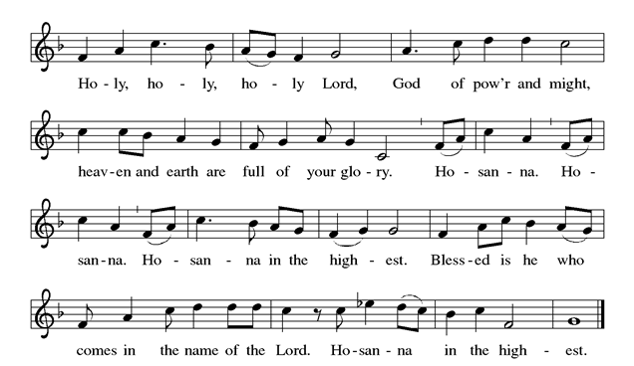
Thanksgiving at the Table
P: In the night in which he was betrayed, our Lord Jesus took bread, and gave thanks; broke it, and gave it to his disciples, saying: Take and eat; this is my body, given for you. Do this for the remembrance of me. Again, after supper, he took the cup, gave thanks, and gave it for all to drink, saying: This cup is the new covenant in my blood shed for you, and for all people for the forgiveness of sin. Do this for the remembrance of me.

Lord's Prayer
P: Gathered into one by the Holy Spirit, let us pray as Jesus taught us.
C: Our Father, who art in heaven, hallowed be thy name, thy kingdom come, thy will be done, on earth as it is in heaven. Give us this day our daily bread; and forgive us our trespasses, as we forgive those who trespass against us; and lead us not into temptation, but deliver us from evil. For thine is the kingdom, and the power, and the glory, forever and ever. Amen.

Lamb of God
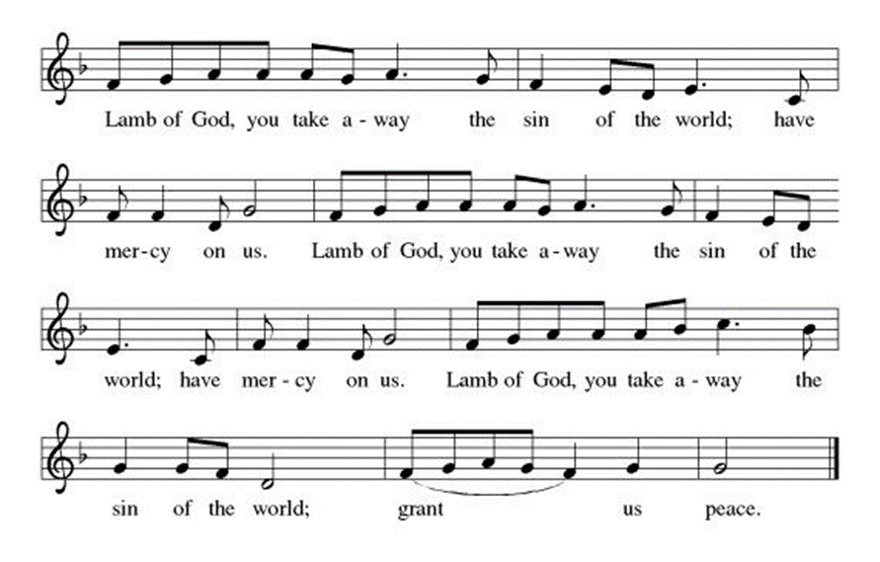

The congregation is invited to sit.
Communion
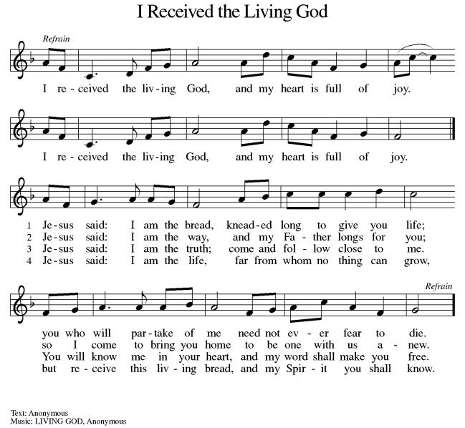

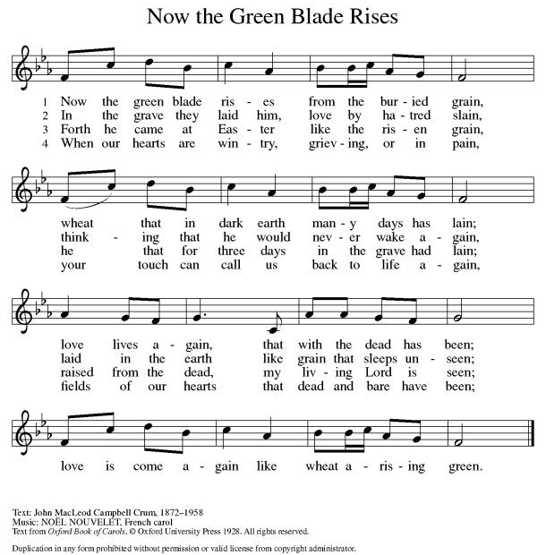

The congregation is invited to stand.

POST COMMUNION BLESSING
P: The body and blood of our Lord Jesus Christ strengthen you and keep you in his grace.
C: Amen

Prayer after Communion
P: Let us pray.
C: Gracious God, in you we live and move and have our being. With your word and this meal of grace, you have nourished our life together. Strengthen us to show your love and serve the world in Jesus’ name. Amen.
Blessing
P: The God of all, who raised ☩ Jesus from the dead, bless you by the power of the Holy Spirit to live in the new creation.
C: Amen.

SENDING HYMN
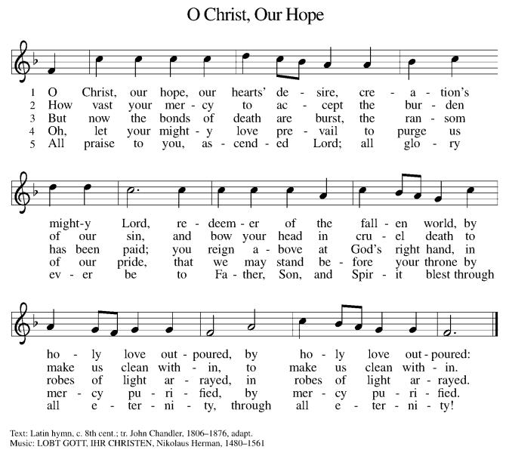

Dismissal
P: Go in peace. Serve the Risen One.
P: Thanks be to God.

Liturgical texts, music and Psalm from Sundays and Seasons.com. Copyright ©2023 Augsburg Fortress. Reprinted under License #SAS103657. Bible readings from New Revised Standard Version Bible, copyright 8022, Division of Christian Education of the National Council of the Churches of Christ in the United States of America. Reprinted by permission.
Now the Feast and Celebration liturgical music reprinted under ONELICENSE.NET, License #A-718405.
Hymns and song texts are reprinted under ONELICENSE.NET, License #A-718405, and/or CCLI, License #2032159.
All items not covered above are ©2022, Christ Evangelical Lutheran Church, All rights reserved.

